**Automated traffic light coordination**

Automated traffic light coordination with sensors aims to optimize traffic flow by adjusting the timing of traffic lights on four roads intersections. Sensors, such as passive infrared (PIR)sensors, are used to detect the presence of vehicles by detecting movement of vehicles. These sensors feed data to an Arduino mega where the control takes place, which adjusts the traffic light timings accordingly based on the real time traffic. For instance, if a sensor detects a buildup of vehicles approaching an intersection, the control system can extend the yellow color for two seconds then green light to allow more vehicles to pass through and automatically assigns the other roads a red color until there are is no motion detected by the sensors. This dynamic adjustment helps reduce congestion and improves overall traffic efficiency by elimination of delays.

The following are the hardware components of the system

**OUTPUT**

1. LED bulbs - 4 red bulbs (r1 indicates vehicles to stop on road 1, r2 indicates vehicles to stop on road 2, r3 indicates vehicles to stop on road 3, r4 indicates vehicles to stop on road 4)

* 4 greed bulbs (g1 indicates vehicles ca move on road 1, g2 indicates vehicles ca move on road 2, g3 indicates vehicles ca move on road 3, g4 indicates vehicles ca move on road 4)
* 4 yellow/orange bulbs (y1 indicates vehicles on road 1 to get ready for two seconds, y2 indicates vehicles on road 2 to get ready for two seconds, y3 indicates vehicles on road 3 to get ready for two seconds, y4 indicates vehicles on road 4 to get ready for two seconds)

**INPUT**

1. 4 Passive Infrared (PIR) sensors (s1 detect motion on road 1, s2 detect motion on road 2, s3 detect motion on road 3, s4 detect motion on road 4

**PROCESSING AND CONNECTION**

1. Arduino Omega – hardware that has a compiler that interprets the C code
2. Jumper wires- for making the connection to all the equipment.
3. 2 Resistors -increase resistance in the circuit.
4. Breadboard – Extend the temporary connection without the need for soldiering.
5. C program – A program that coordinates the switching on and off of all the LED bulbs based on the various input from the sensors.

In 4-road intersection traffic lights, there are four sets of traffic signals collected from each of the roads by the four passive infrared sensors (s1, s2, s3 and s4) and sent to the Arduino mega. Each traffic light has three colored lights - red, yellow, and green - that cycle through to regulate the right-of-way for vehicles. The signals are synchronized to ensure safe and efficient traffic management at the intersection. The yellow LED only lights for 2 seconds during the transition from red to green to indicate vehicles to get ready before the transitions.

**Scenerio1** when there are no vehicles in all the roads all red LEDs are on.

**Scenerio2** when there is a vehicle on road 1 the sensor the LED only the green LED on road 1 will be on while the rest remain off. The LEDs on the other roads all show the red color.

**Scenerio3** when there is a vehicle on road 2 the sensor the LED only the green LED on road 2 will be on while the rest remain off. The LEDs on the other roads all show the red color.

**Scenerio4** when there is a vehicle on road 3 the sensor the LED only the green LED on road 3 will be on while the rest remain off. The LEDs on the other roads all show the red color.

**Scenerio5** when there is a vehicle on road 4 the sensor the LED only the green LED on road 4 will be on while the rest remain off. The LEDs on the other roads all show the red color.

**Scenario 6** when there is a vehicle on road 1 and road 2 the sensor the LED only the green LED on road 1 will be on while the rest remain off then turn of the green light on road 2 while the rest remain off apart from red.

**Scenerio7** when there is a vehicle on road 1 and road 3 the sensor the LED only the green LED on road 1 will be on while the rest remain off then turn of the green light on road 3 while the rest remain off apart from red.

**Scenerio8** when there is a vehicle on road 1 and road 4 the sensor the LED only the green LED on road 1 will be on while the rest remain off then turn of the green light on road 4 while the rest remain off apart from red.

**Scenerio9** when there is a vehicle on road 2 and road 3 the sensor the LED only the green LED on road 2 will be on while the rest remain off then turn of the green light on road 3 while the rest remain off apart from red.

**Scenerio10** when there is a vehicle on road 2 and road 4 the sensor the LED only the green LED on road 2 will be on while the rest remain off then turn of the green light on road 4 while the rest remain off apart from red.

**Scenerio11** when there is a vehicle on road 3 and road 4 the sensor the LED only the green LED on road 3 will be on while the rest remain off then turn of the green light on road 4 while the rest remain off apart from red.

**Scenario 12** when there is a vehicle on road 1, road 2 and road 3 the sensor the LED only the green LED on road 1 will be on while the rest remain off then turn of the green light on road 2 while the rest remain off, then turn the green light on road 3 while the rest remain off apart from red.

**Scenario 13** when there is a vehicle on road 1, road 2 and road 4 the sensor the LED only the green LED on road 1 will be on while the rest remain off then turn of the green light on road 2 while the rest remain off, then turn the green light on road 4 while the rest remain off apart from red.

**Scenario 14** when there is a vehicle on road 1, road 3 and road 4 the sensor the LED only the green LED on road 1 will be on while the rest remain off then turn of the green light on road 3 while the rest remain off, then turn the green light on road 4 while the rest remain off apart from red.

**Scenario 15** when there is a vehicle on road 2, road 3 and road 4 the sensor the LED only the green LED on road 2 will be on while the rest remain off then turn of the green light on road 3 while the rest remain off, then turn the green light on road 4 while the rest remain off apart from red.

**Scenario 16** when there is a vehicle on road 1, on road 2, road 3 and road 4 the sensor the LED only the green LED on road 1 will be on while the rest remain off then turn of the green light on road 2 while the rest then turn of the green light on road 3 while the rest remain off apart from red, then turn the green light on road 4 while the rest remain off apart from red.

Below is the code that controls the above

const int g1 = 3; // Green light pin

const int y1 = 2; // Yellow light pin

const int r1 = 13; // Red light pin

const int g2 = 6; // Green light pin

const int y2 = 5; // Yellow light pin

const int r2 = 4; // Red light pin

const int g3 = 9; // Green light pin

const int y3 = 8; // Yellow light pin

const int r3 = 7; // Red light pin

const int g4 = 12; // Green light pin

const int y4 = 11; // Yellow light pin

const int r4 = 10; // Red light pin

const int s4 = A5; // Sensor pin

const int s3 = A4;

const int s2 = A3;

const int s1 = A2;

int currentPriority = 0;

void setup() {

  pinMode(g1, OUTPUT);

  pinMode(y1, OUTPUT);

  pinMode(r1, OUTPUT);

  pinMode(s1, INPUT);

  pinMode(y2, OUTPUT);

  pinMode(r2, OUTPUT);

  pinMode(s2, INPUT);

  pinMode(g3, OUTPUT);

  pinMode(y3, OUTPUT);

  pinMode(r3, OUTPUT);

  pinMode(s3, INPUT);

  pinMode(g4, OUTPUT);

  pinMode(y4, OUTPUT);

  pinMode(r4, OUTPUT);

  pinMode(s4, INPUT);

**Serial**.begin(9600); // Initialize serial communication at 9600 baud rate

}

void loop() {

  int sensorValue1 = analogRead(s1);

  int sensorValue2 = analogRead(s2);

  int sensorValue3 = analogRead(s3);

  int sensorValue4 = analogRead(s4);

   if ((sensorValue1 == 1023) && (sensorValue3 == 1023) && (sensorValue4 == 1023)){

    // sensor1, sensor3 and sensor4 detects motion

    if (currentPriority == 1) {

      digitalWrite(g2, LOW);

      digitalWrite(g3, LOW);

      digitalWrite(g1, HIGH);

      digitalWrite(g4, LOW);

    }

   else if (currentPriority == 3) {

      digitalWrite(g1, LOW);

      digitalWrite(g2, LOW);

      digitalWrite(g3, HIGH);

      digitalWrite(g4, LOW);

    }

    else if (currentPriority == 4) {

      digitalWrite(g1, LOW);

      digitalWrite(g2, LOW);

      digitalWrite(g3, LOW);

      digitalWrite(g4, HIGH);

    } else {

      currentPriority = 0;

    }}if ((sensorValue1 == 1023) && (sensorValue2 == 1023) && (sensorValue4 == 1023)){

    // sensor1, sensor2 and sensor4 detects motion

    if (currentPriority == 1) {

      digitalWrite(g2, LOW);

      digitalWrite(g3, LOW);

      digitalWrite(g1, HIGH);

      digitalWrite(g4, LOW);

    }

   else if (currentPriority == 2) {

      digitalWrite(g1, LOW);

      digitalWrite(g3, LOW);

      digitalWrite(g2, HIGH);

      digitalWrite(g4, LOW);

    }

    else if (currentPriority == 4) {

      digitalWrite(g1, LOW);

      digitalWrite(g2, LOW);

      digitalWrite(g3, LOW);

      digitalWrite(g4, HIGH);

    }

    else {

      currentPriority = 0;

    }} if ((sensorValue1 == 1023) && (sensorValue2 == 1023) && (sensorValue3 == 1023)){

    // sensor1, sensor2 and sensor3 detects motion

    if (currentPriority == 1) {

      digitalWrite(g2, LOW);

      digitalWrite(g3, LOW);

      digitalWrite(g1, HIGH);

      digitalWrite(g4, LOW);

    }

   else if (currentPriority == 2) {

      digitalWrite(g1, LOW);

      digitalWrite(g3, LOW);

      digitalWrite(g2, HIGH);

      digitalWrite(g4, LOW);

    }

    else if (currentPriority == 3) {

      digitalWrite(g1, LOW);

      digitalWrite(g2, LOW);

      digitalWrite(g4, LOW);

      digitalWrite(g3, HIGH);

    } else {

      currentPriority = 0;

    }

  } else if ((sensorValue2 == 1023) && (sensorValue3 == 1023) && (sensorValue4 == 1023)){

    // sensor2, sensor3 and sensor4 detects motion

    if (currentPriority == 2) {

      digitalWrite(g1, LOW);

      digitalWrite(g3, LOW);

      digitalWrite(g2, HIGH);

      digitalWrite(g4, LOW);

    }

   else if (currentPriority == 3) {

      digitalWrite(g1, LOW);

      digitalWrite(g2, LOW);

      digitalWrite(g3, HIGH);

      digitalWrite(g4, LOW);

    }

    else if (currentPriority == 4) {

      digitalWrite(g1, LOW);

      digitalWrite(g2, LOW);

      digitalWrite(g3, LOW);

      digitalWrite(g4, HIGH);

    }

    else {

      currentPriority = 0;

    }

  } else if ((sensorValue1 == 1023) && (sensorValue4 == 1023)){

    // sensor1 and sensor4 detects motion

   if (currentPriority == 1) {

      digitalWrite(g3, LOW);

      digitalWrite(g2, LOW);

      digitalWrite(g1, HIGH);

      digitalWrite(g4, LOW);

    }

    else if (currentPriority == 4) {

      digitalWrite(g1, LOW);

      digitalWrite(g2, LOW);

      digitalWrite(g3, LOW);

      digitalWrite(g4, HIGH);

    }

  } else if ((sensorValue1 == 1023) && (sensorValue3 == 1023)){

    // sensor1 and sensor3 detects motion

   if (currentPriority == 1) {

      digitalWrite(g1, HIGH);

      delay(3000);

      digitalWrite(g3, LOW);

      digitalWrite(g2, LOW);

      digitalWrite(g4, LOW);

    }

    else if (currentPriority == 3) {

      digitalWrite(g3, HIGH);

      delay(3000);

      digitalWrite(g1, LOW);

      digitalWrite(g2, LOW);

      digitalWrite(g4, LOW);

    }

  } else if ((sensorValue1 == 1023) && (sensorValue2 == 1023)){

    // sensor1 and sensor2 detects motion

   if (currentPriority == 1) {

      digitalWrite(g1, HIGH);

      delay(3000);

      digitalWrite(g3, LOW);

      digitalWrite(g2, LOW);

      digitalWrite(g4, LOW);

    }

    else if (currentPriority == 2) {

      digitalWrite(g2, HIGH);

      delay(3000);

      digitalWrite(g1, LOW);

      digitalWrite(g3, LOW);

      digitalWrite(g4, LOW);

    }

  } else if ((sensorValue3 == 1023) && (sensorValue4 == 1023)){

    // sensor3 and sensor4 detects motion

   if (currentPriority == 3) {

      digitalWrite(g1, LOW);

      digitalWrite(g2, LOW);

      digitalWrite(g3, HIGH);

      digitalWrite(g4, LOW);

    }

    else if (currentPriority == 4) {

      digitalWrite(g1, LOW);

      digitalWrite(g2, LOW);

      digitalWrite(g3, LOW);

      digitalWrite(g4, HIGH);

    }

  } else if ((sensorValue2 == 1023) && (sensorValue3 == 1023)){

    // sensor2 and sensor3 detects motion

   if (currentPriority == 2) {

      digitalWrite(g2, HIGH);

      delay(3000);

      digitalWrite(g1, LOW);

      digitalWrite(g3, LOW);

      digitalWrite(g4, LOW);

    }

    else if (currentPriority == 3) {

      digitalWrite(g3, HIGH);

      delay(3000);

      digitalWrite(g1, LOW);

      digitalWrite(g2, LOW);

      digitalWrite(g4, LOW);

    }

  } else if ((sensorValue2 == 1023) && (sensorValue4 == 1023)){

    // sensor2 and sensor4 detects motion

   if (currentPriority == 2) {

      digitalWrite(g2, HIGH);

      delay(3000);

      digitalWrite(g1, LOW);

      digitalWrite(g3, LOW);

      digitalWrite(g4, LOW);

    }

    else if (currentPriority == 4) {

      digitalWrite(g4, HIGH);

      delay(3000);

      digitalWrite(g1, LOW);

      digitalWrite(g2, LOW);

      digitalWrite(g3, LOW);

    }

  } else if(sensorValue4 == 1023) {

    // if sensor4 detects motion

    if (currentPriority != 4) {

      currentPriority = 4;

      digitalWrite(y4, HIGH);

      delay(2000);

      digitalWrite(y4, LOW);

    }

    digitalWrite(g4, HIGH);

    delay(3000);

    digitalWrite(g3, LOW);

    digitalWrite(g2, LOW);

    digitalWrite(g1, LOW);

    digitalWrite(r1, HIGH);

    digitalWrite(r2, HIGH);

    digitalWrite(r3, HIGH);

    digitalWrite(r4, LOW);

  } else if (sensorValue3 == 1023) {

    // if sensor3 detects motion

    if (currentPriority != 3) {

      currentPriority = 3;

      digitalWrite(y3, HIGH);

      delay(2000);

      digitalWrite(y3, LOW);

    }

    digitalWrite(g3, HIGH);

    delay(3000);

    digitalWrite(g4, LOW);

    digitalWrite(g2, LOW);

    digitalWrite(g1, LOW);

    digitalWrite(r1, HIGH);

    digitalWrite(r2, HIGH);

    digitalWrite(r4, HIGH);

    digitalWrite(r3, LOW);

  } else if(sensorValue2 == 1023) {

    // if sensor2 detects motion

    if (currentPriority != 2) {

      currentPriority = 2;

      digitalWrite(y2, HIGH);

      delay(2000);

      digitalWrite(y2, LOW);

    }

    digitalWrite(g2, HIGH);

    delay(3000);

    digitalWrite(g1, LOW);

    digitalWrite(g3, LOW);

    digitalWrite(g4, LOW);

    digitalWrite(r1, HIGH);

    digitalWrite(r2, LOW);

    digitalWrite(r3, HIGH);

    digitalWrite(r4, HIGH);

  }else if(sensorValue1 == 1023) {

    // if sensor1 detects motion

    if (currentPriority != 1) {

      currentPriority = 1;

      digitalWrite(y1, HIGH);

      delay(2000);

      digitalWrite(y1, LOW);

    }

    digitalWrite(g1, HIGH);

    delay(3000);

    digitalWrite(g2, LOW);

    digitalWrite(g3, LOW);

    digitalWrite(g4, LOW);

    digitalWrite(r2, HIGH);

    digitalWrite(r1, LOW);

    digitalWrite(r3, HIGH);

    digitalWrite(r4, HIGH);

  } else {

    // If no sensor detects motion

    currentPriority = 0;

    digitalWrite(g4, LOW);

    digitalWrite(y4, LOW);

    digitalWrite(r4, HIGH);

    digitalWrite(g3, LOW);

    digitalWrite(y3, LOW);

    digitalWrite(r3, HIGH);

    digitalWrite(g2, LOW);

    digitalWrite(y2, LOW);

    digitalWrite(r2, HIGH);

    digitalWrite(g1, LOW);

    digitalWrite(y1, LOW);

    digitalWrite(r1, HIGH);

  }

**Serial**.print("Sensor value 1: ");

**Serial**.println(sensorValue1);

**Serial**.print("Sensor value 2: ");

**Serial**.println(sensorValue2);

**Serial**.print("Sensor value 3: ");

**Serial**.println(sensorValue3);

**Serial**.print("Sensor value 4: ");

**Serial**.println(sensorValue4);

  delay(1000);

}

Below is the samples of the working prototypes

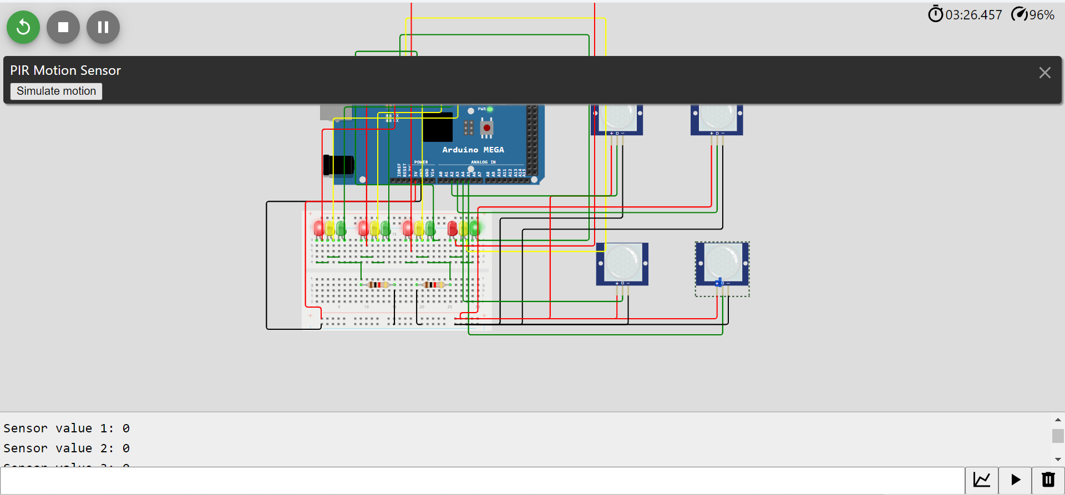

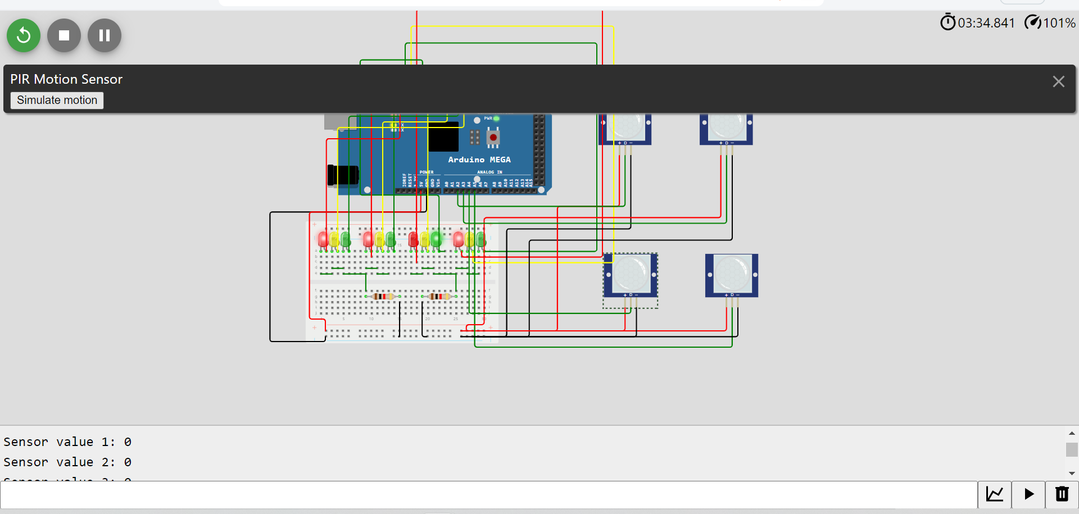

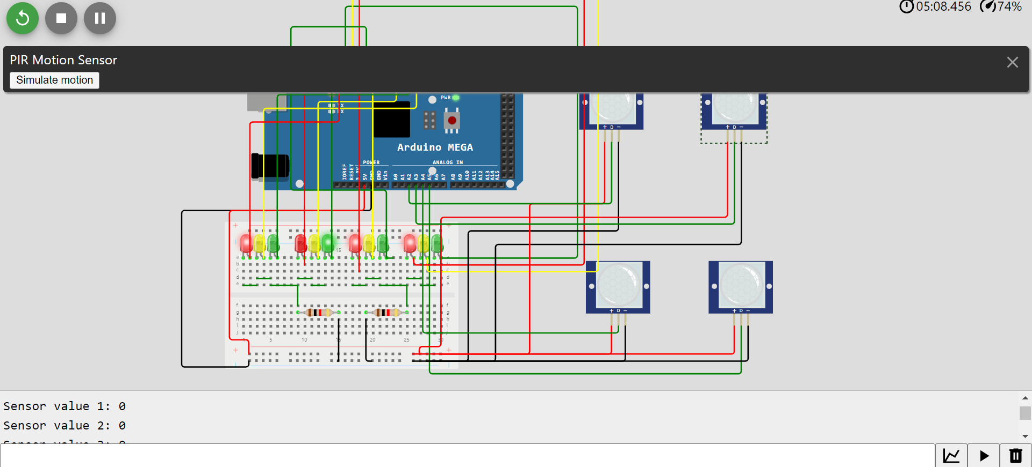

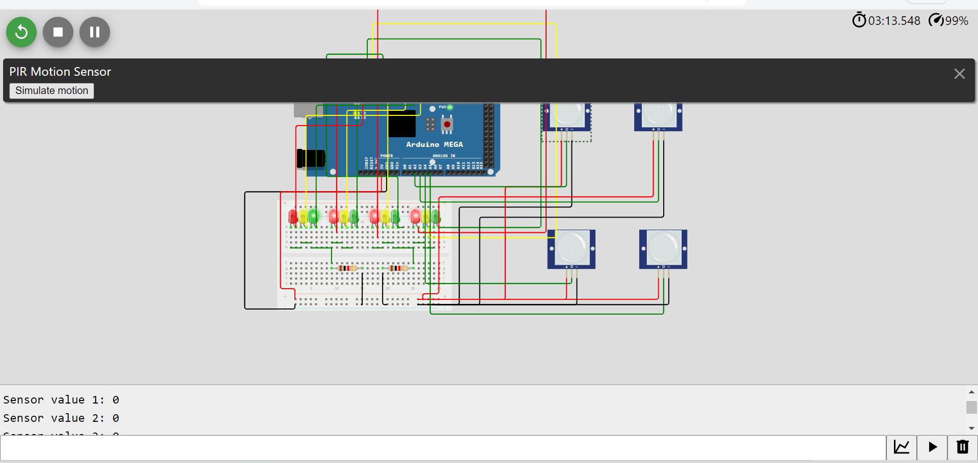

**Discussion**

The Passive infrared sensors may not give the exact value 1023 when there is motion such as in the above simulation due to various reason such presence of an electromagnetic fields. The passive infrared sensors may be manipulated making it faulty thus interfering with the efficiency of the system.